**Questions For DCJ paper revision**

1. Mention the difference from the manual diagram we proposed(for VINCI) using IPE and to new visualization (circular DCJ O)

* Initial graphs created using IPE

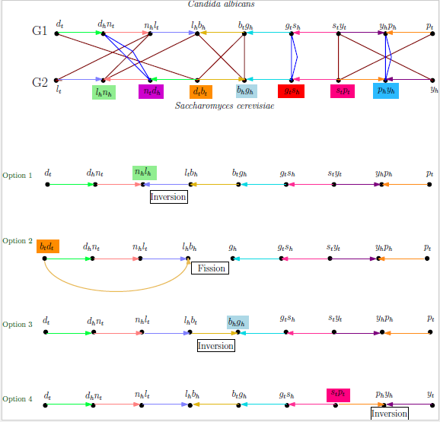

* + Disadvantage: not scalable for large data sets – (as representing as linear horizontal representation ) Adaptability to larger genomes and interactive display of intermediate steps
  + Disadvantage: Time consuming (Manually)
  + Disadvantage: Complexity increases with size of genome
  + Advantage:
    - can construct to show the adjacency graph which is helps to determine the total number of steps for the genome rearrangement
    - Also, we annotate each operation
* Intermediate ( BiBiserv2)
  + Existing visualization tool – reads text file with gene labels and displays the steps in horizontal fashion
  + 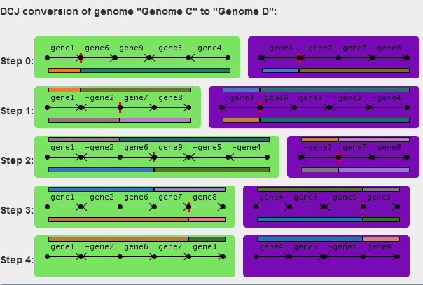
  + Advantage: automated
  + Disadvantage:
    - Adaptability for large data sets – hard to visualize
    - Adjacency graph not displayed
  + Performed operation not clear the color coordination showed for genes not consistent
* The new DCJ visualization – Circular Color map
  + Advantage:
    - Automate the visualization
    - Adaptability – with zoom in for detailed of gene and location
    - Pop-up with gene info
    - show intermediate steps leading to complete genome rearrangement for Source Genome into Target Genomes
    - Adjacency graph links are depicted with the same color in the source and target genome.
    - The idea is for the source to look like a COLOR PUZZLE to display discrepancy.
  + Data: accepts in fasta format ( specifically Multi-FASTA representing nucleotide sequence for each gene – NCBI data set) . Extension will include to also accept normal text file with simple letter representation like previous tools ( GenomeA: a b –c d)
    - Challenges faced to change input data format from Multi-FASTA and GenBank File for the color map.
    - The location and gene position not consecutive in both sets of data

1. How new visualization displays 1 possible way compare to all possible way (as in figure 8 with 4 options for the 1st step )
   1. Next submission : intermediate program which can detect and list of say what the operations @ each step (inversion, fusion , fission 🡪 may be can use SORT^2) for given scenario
   2. Explain how circular and linearized chromosome are separated. Also, Explain how each operation is visualized
   3. Circular 🡪 will full gray circular arc
   4. Show pictures for fission(circularization), fusion (linearization), inversion, translocation

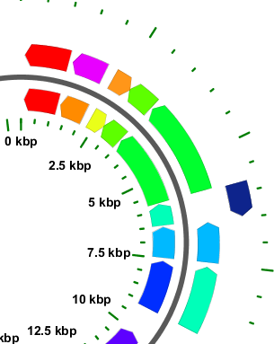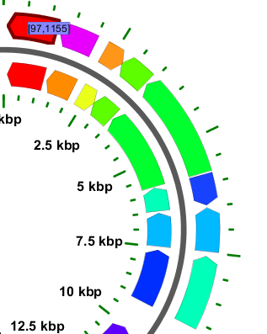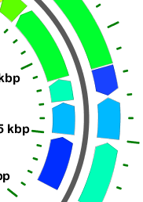

Inversion

Fission

Fusion

* 1. Also, Explain why are showing the visualization as O circular.

Scalabiility 🡪 easy to view even when there are n number of genes for given genomes

1. Search if there are programs that will give the operations performed given 🡪 original Sequence and 🡪 Changed Sequence
   1. SORT^2 by 2010: a tool for sorting genomes and reconstructing phylogenetic trees by reversals, generalized, transpositions and translocation!
      1. Paper sorting genome into another genome with 3 types of operations
2. Talk/cite(update) about the programs we used
   1. CGview
      1. Stothard P, Wishart DS. Circular genome visualization and exploration using CGView. Bioinformatics 21:537-539.
   2. BibiServer

*Bergeron, A. and Mixtacki, J. and Stoye, J.* [**Chapter 10: The inversion distance problem.**](http://dx.doi.org/10.1093/bib/bbn036), , 2005

1. Usefulness 🡪 add survey section